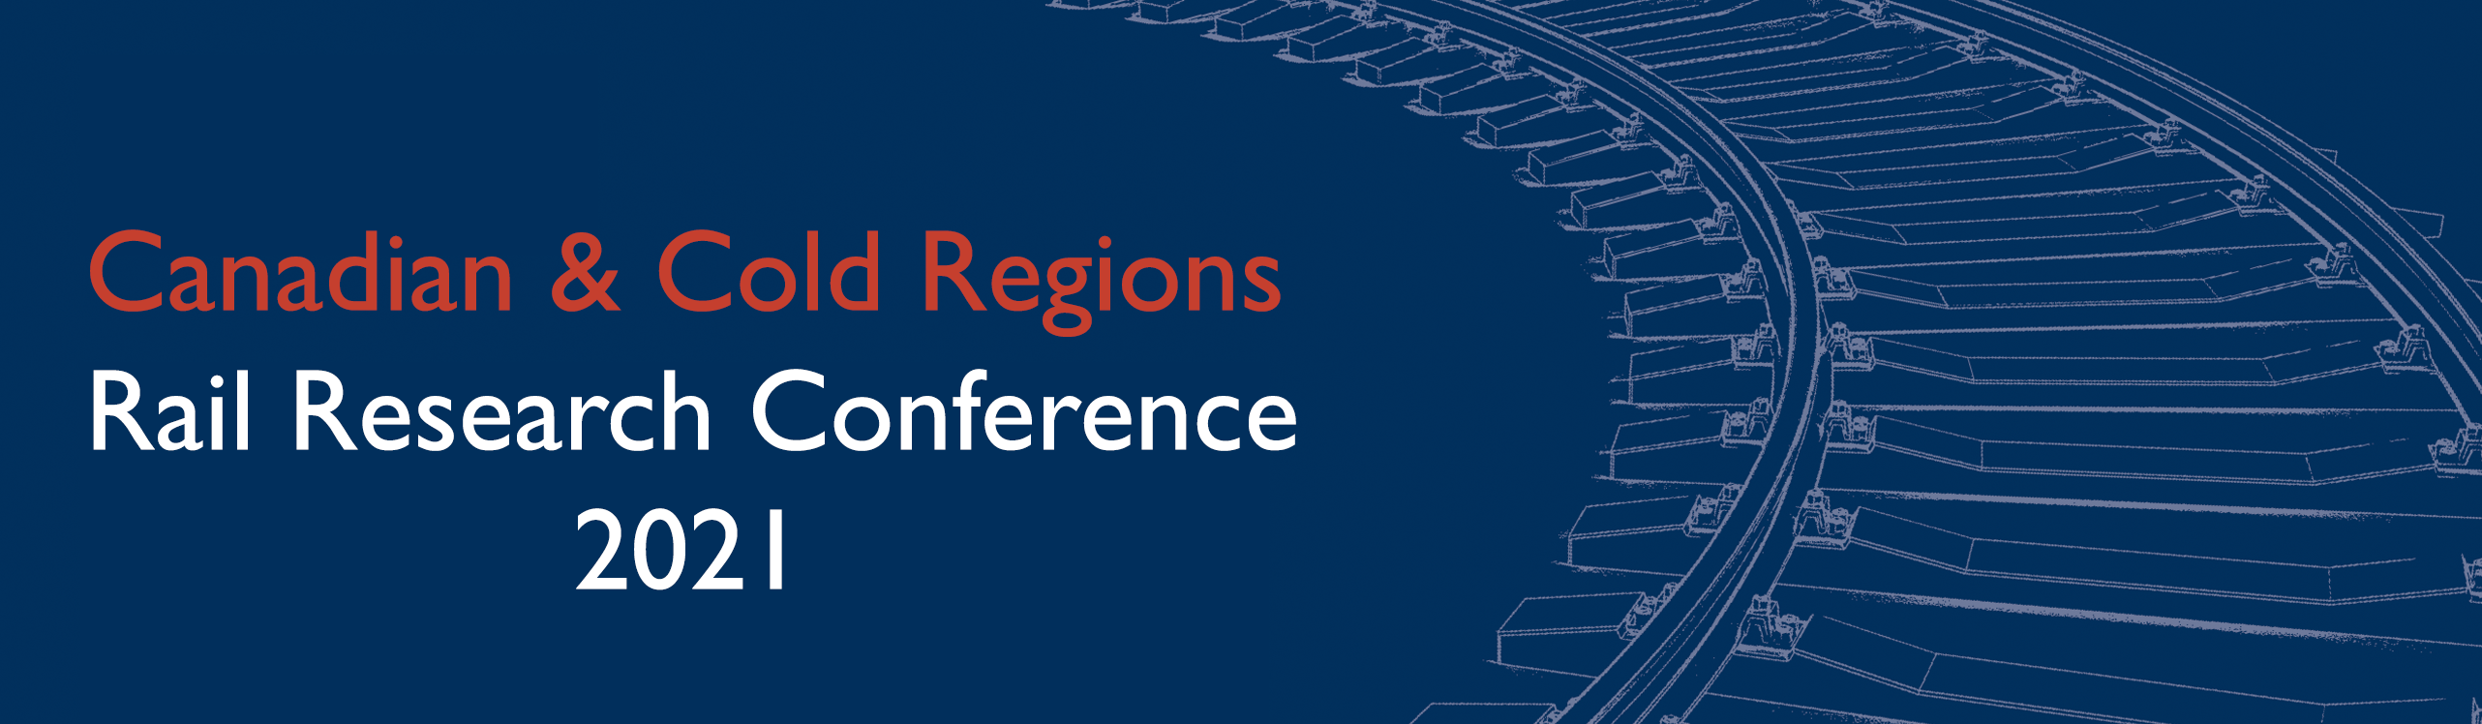

The Canadian Rail Research Laboratory is proud to host the
Canadian & Cold Regions Rail Research Conference on November 9-10, 2021!

Professionals and researchers involved with railway engineering are invited to participate in the Canadian & Cold Regions Rail Research Conference. Conference participants will have opportunities to present ideas, learn of new developments and technologies, make professional contacts and discuss issues related to railway engineering in Canada and cold regions. The program will include sessions by practitioners and experts on the following general topics and themes of the conference:

Climate Change and Environment  - Sustainability/resiliency  - Environmental regulations  - Planning and environmental considerations  - Design/construction/maintenance | Operations  - Operation and maintenance  - Intermodal or multi-modal rail operations  - Data driven maintenance planning  - Communications
Cold Regions Engineering  - Frozen soils/permafrost  - Rail break mitigation and detection technologies  - Train braking systems | Human Factors  - Railway transportation safety  - Grade crossings and trespassing  - Training
Innovations in Railway Engineering  - Advanced technologies for monitoring  - Materials technology and innovation  - Design/testing/construction/maintenance  - Data asset management | Risk and Reliability  - Vehicle/track performance  - Transportation of dangerous goods  - Ground hazards  - Improved interline reliability and supply chain transparency
Enhanced Train Control
- Technology and automation
- Communication and signalling

Abstracts
Prospective authors are invited to submit short abstracts (prepared in English) limited to 300 words including a short title and the names of all the authors and their affiliations (see template below). Abstracts must be submitted to Dr. Parisa Haji Abdulrazagh (hajiabdu@ualberta.ca) by April 26, 2021.

Please indicate whether you will intend to submit a full paper (8-10 pages) or a short paper (4 pages with few images). Graduate students are expected to submit full papers.

Authors will be notified of acceptance on a rolling basis. All authors will receive confirmation no later than May 15, 2021. Full and short papers are due September 15, 2021. More details will be available in the coming weeks on www.carrl.ca

SPONSORSHIP
Organizations interested in sponsoring the Conference are encouraged to contact Vivian Giang (viviang@ualberta.ca).

(Title)
Formatting guidelines and abstract template for CCRC 2021
Author One, Author Two, & Author Three
Company Name, City, Province/State, Country
Author Four, Author Five, & Author Six
Department of XX – University of YY, City, Province/State, Country

Is this a:____ Full paper? ____Short paper?
Please indicate the conference themes that your abstract is related to.

ABSTRACT
Abstracts may be submitted in English, and must not exceed a total of 300 words. Arial font is used throughout – the title is 14 point bold, the author section is 10 point, and the abstract text is 9 point on single line spacing.
The abstract must be submitted to Dr. Parisa Haji Abdulrazagh (hajiabdu@ualberta.ca) and must be received before the close of abstract submissions on April 26, 2021. Please ensure that you spell check your abstract and review it for correct grammar. You will be advised of acceptance of your abstract no later than May 15, 2021.

